1. Basic operation
2. Not commutative: 
3. Associative: 
4. : transpose of A
5. If, then A is symmetric
6. AB = 0 does NOT mean A = 0 or B = 0
7. Inner Product & outer product

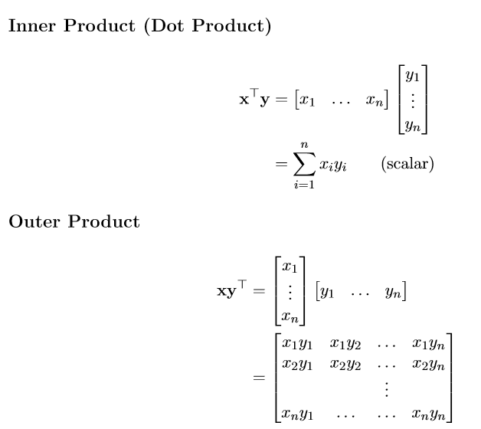

Outer product  does not exist

Rank(A): number of linearly independent rows/columns of A

1. System of Linear Equations
2. Solving the Linear Equation

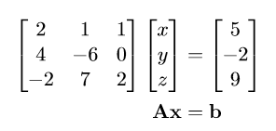

1. Fundamental Subspaces
2. Column space

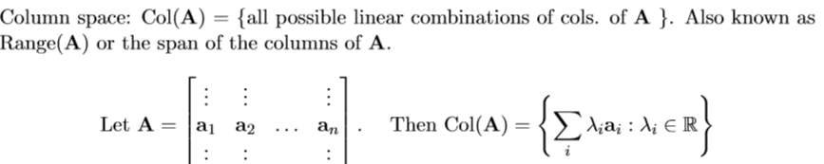

1. Null space ( Null(A)={x: Ax=0} )

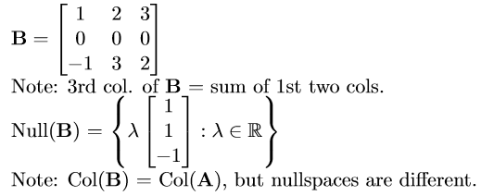

1. Row space: 
2. Left-nullspace：Nul(A)
3. Norm

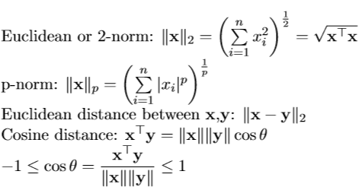

1. Orthonormal

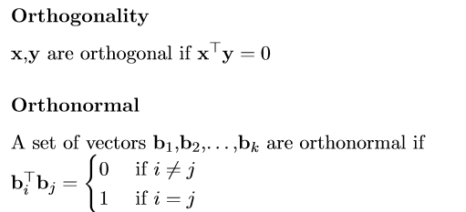

A matrix Q is orthogonal if QTQ = I

e.g.  is an orthogonal matrix.

1. Gram-Schmidt(Useful way to calculate Ax=b, Cause it is difficult to get A-1)
2. Eigenvector & Eigenvalue

det(A): det(AB)=det(A)det(B)

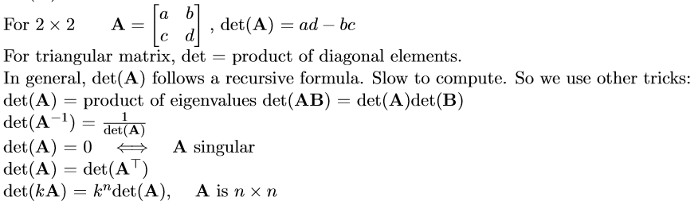

trace(A)= sum of eigenvalue

= sum of diagonal elements

1. Spectral theorem

If A is symmetric

Then AE =E\*nameda

Such that ETE=I, E is orthogonal